**Tutor Match CRM – Phase 3: Data Modeling & Relationships**

Define and implement the data structure of Tutor Match CRM to link **Parents, Tutors, Applications (Bookings), and Sessions**. Configure **record types, page layouts, navigation tabs, and security** so that each role (Admin, Tutor, Parent, Manager, Customer Support) can perform its tasks efficiently.

**1. Standard & Custom Objects**

* **User (Standard):** Represents system users such as Tutors, Parents, Manager, and Admin.
* **Candidate (Tutor – Custom):** Captures tutor information and tracks their availability, expertise, and sessions. Includes fields for Skills, Experience, Contact Details, and lookup relationships to Applications.
* **Job Post (Custom):** Stores tutoring requests created by Parents. Includes fields for Description, Location, Salary, and Job Type.
* **Application (Custom):** Tracks bookings made by Parents for specific Job Posts. Includes fields for Status, Applied Date, and lookups to Candidate and Job Post.
* **Interview / Session (Custom):** Stores scheduled tutoring sessions. Includes fields for Session Date/Time, Mode (Online/Offline), and Master-Detail relationship to Application.

**2. Fields**

* **Candidate (Tutor):**
  + Name, Email, Phone, Skills, Experience, Availability
  + Links to Applications and Sessions for tracking assigned tutoring jobs
* **Job Post:**
  + Description, Location, Salary, Job Type (Picklist: Part-Time, Full-Time, Online)
  + Links to Applications to show which Tutors applied
* **Application:**
  + Status (Applied, Shortlisted, Rejected, Hired), Applied Date
  + Lookup to Candidate (Tutor) and Job Post
* **Interview / Session:**
  + Session Date/Time, Mode (Online/Offline)
  + Master-Detail relationship to Application
  + Lookup to Interviewer (User)

**3. Record Types**

* **Candidate:** Full-Time Tutor, Part-Time Tutor
* **Job Post:** Online Request, Offline Request

**4. Page Layouts & Related List**

* **Candidate Page Layout:** Shows tutor details, skills, availability, and related Applications
* **Job Post Page Layout:** Displays Job details and related Applications
* **Application Page Layout:** Shows Status, Candidate, Job Post, and related Sessions
* **Interview / Session Page Layout:** Displays session details and links to Application
* Each record type has a separate page layout to display relevant fields A screenshot of a computer

  AI-generated content may be incorrect.  
  
  
  
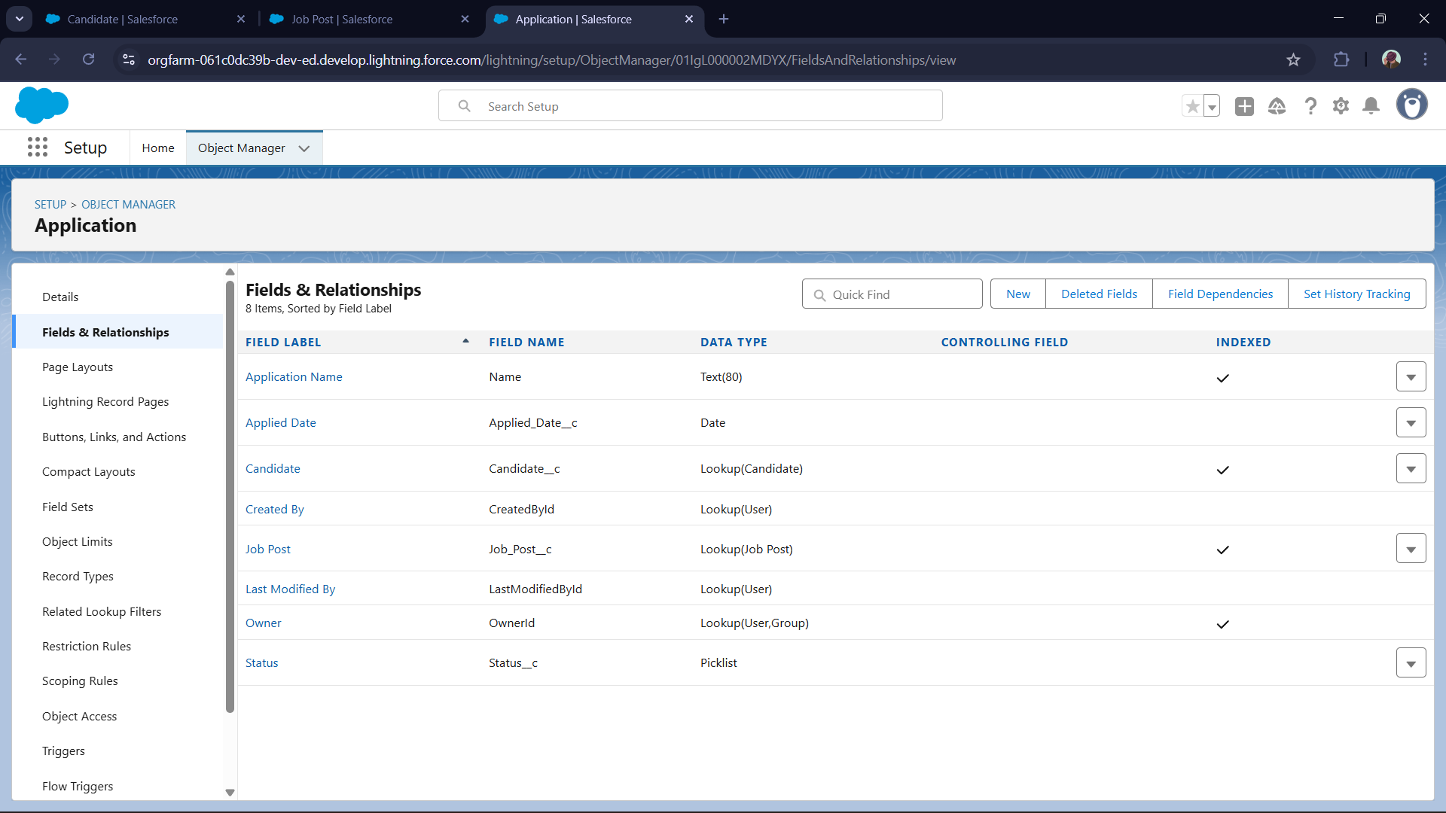  
  
  
**5. Lightning Record Pages & Compact Layouts**

**Purpose:** Provide a tailored view for different users; highlight key fields for quick access.

**Key Fields for Compact Layouts:**

* Job Post: Job Title, Location, Salary
* Candidate: Name, Skills, Availability
* Application: Status, Job Post, Candidate  
  
  
  
**8. Schema Builder**

**Usage**: Visualize object models, add or edit fields/relationships, and see dependencies dynamically.

* **Illustrative relationships for Tutor Match**:  
   • One **Tutor** → Many **Booking**  
   • One **Booking** → Many **Session**  
   • One **Session** → Many **Feedback**  
   • One **Booking** → Many **Payment**  
   • Many **Tutor** ↔ Many **Subject** via **TutorSubject** junction object  
    
  A screenshot of a computer

  AI-generated content may be incorrect.  
    
    
  **9. Junction Objects**
* ❖ **Purpose:** To implement many-to-many relationships (e.g. Tutor ↔ Subject).  
  ❖ **In Tutor Match CRM:** I created a separate junction object **TutorSubject__c** to link **Tutor** and **Subject**. Each Tutor can teach multiple Subjects, and each Subject can be taught by multiple Tutors.  
  ❖ **Why separate it:** Without a junction, you’d need to duplicate or complicate relationships. The junction object makes it scalable and clean.  
  ❖ **Optional extra fields:** In **TutorSubject__c**, you can include fields such as **Proficiency** or **IsPrimarySubject** to capture more detail about each linking record.
* 10.External Objects (Future Scope)
* • Let Salesforce access data stored outside its database without duplicating it.
* • In Tutor Match, you could map an external “Tutor Directory” or external “Payment Ledger” into Salesforce as external objects.
* • Use Salesforce Connect to sync external data and relate it to your internal objects (Tutor, Booking, etc.).
* • External objects behave like custom objects but point to external sources
* .